**Disk Image Utility**

**20 December 2021**

**Darrell Pelan**

**Rev 1.1e**

Table of Contents

Introduction 1

Supported File Types 2

Home Screen 3

Windows 3

Function Buttons 5

Folder 5

File List 5

Extract 5

View 5

Delete 5

IMD Convert 5

H8D Convert to Soft Sector 5

Add CP/M / Add MS-DOS (IMG and H8D only) 6

Create an Empty File 6

Appendix 8

Disk Format Details 8

File Conversion Notes 9

# Introduction

Disk Image Utility is designed to support using Flash Floppy or HxC flashed Gotek drives with Heathkit 1980 era computers. It supports the native disk formats using IMG files and allows you to extract and add files from your PC to the disk image file. It currently supports CP/M and MS-DOS FAT 12 formats used by the H-8, H-89, and Z-100.

If you want to copy files between images you must first extract the file and then insert the file in another image. This process is explained in the Button section below.

Disk Image Utility can also create blank disk images in several CP/M and MS-DOS formats which you can use in a Flash Floppy or HxC flashed Gotek. Disk Image Utility also supports adding files to these images.

## Supported File Types

The table below summarizes the capabilities for each file type. There is no need to convert an H8D file to IMD since the HxC Floppy Emulator supports the H8D format. IMD formats are converted to IMG. IMG and H37 files are converted to IMD. H37 format is only included due to my work on the H8D Utility program. Since working with IMG files and the Flash Floppy Gotek, the H37 format is not really needed.

|  |  |  |  |  |  |
| --- | --- | --- | --- | --- | --- |
| **Image** | **Directory** | **Extract** | **View** | **Insert** | **Convert Format** |
| H8D | Y | Y | Y | Y | To IMG |
|  |  |  |  |  |  |
| IMD DOS |  |  |  |  | Y |
| IMD H37 | Y | Y |  |  | Y |
| IMD CP/M | Y | Y |  |  | Y |
|  |  |  |  |  |  |
| IMG CP/M | Y | Y | Y | Y | Y |
| IMG DOS | Y | Y | Future | Y | Y |
|  |  |  |  |  |  |
| H37 | Y | Y | Y | Y | y |
|  |  |  |  |  |  |
|  | Feature not supported | | |  |  |
|  | Note IMG DOS files must end in "DOS.IMG" | | | | |

# Home Screen

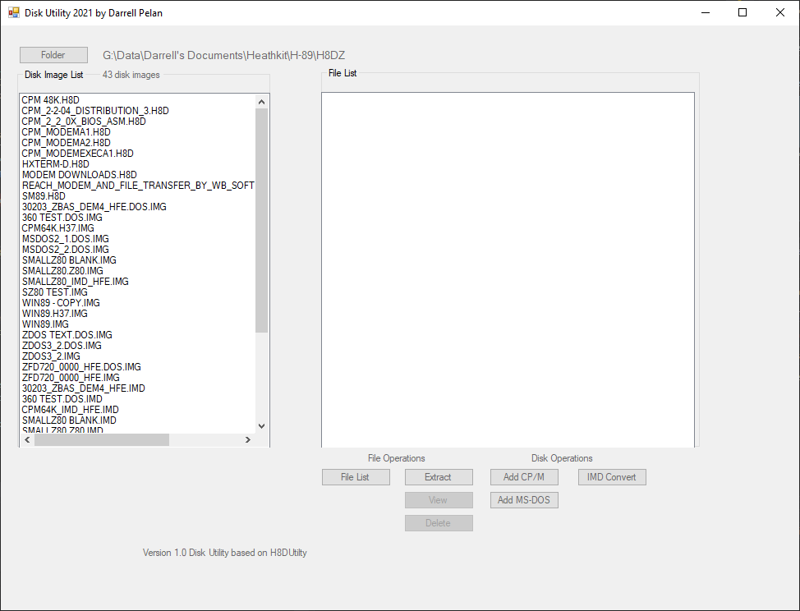

## Windows

The **Disk Image List** shows the disk images in the target directory. Disk Image Utility starts in the last target directory used by the program. You can change the target directory using the **Folder** button.

The **File List** box shows the files in the images currently selected in the Disk Image List box when you click the **File List** button. If no images are selected, all file images are processed. CP/M file lists show the user area and status flags for each file. MS-DOS files show the flags, date and time for each file. Sub-Directories are only supported one level deep. Files in a sub directory of a sub directory will not display and cannot be extracted.

The **File List** window supports **copying the file listing** by left clicking with your mouse and then pasting the information in another application. There is no indication that the list copy occurred when you left click in the window.

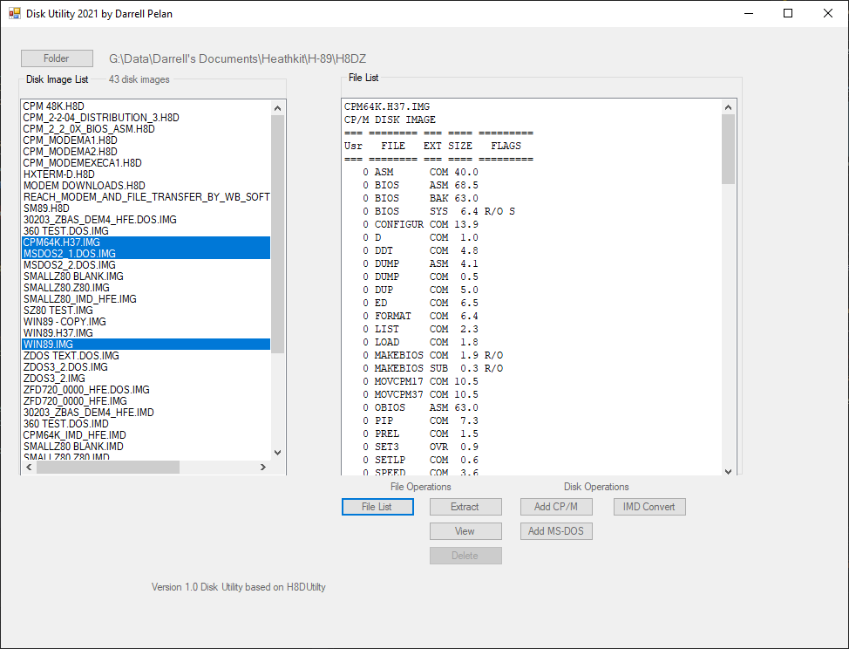

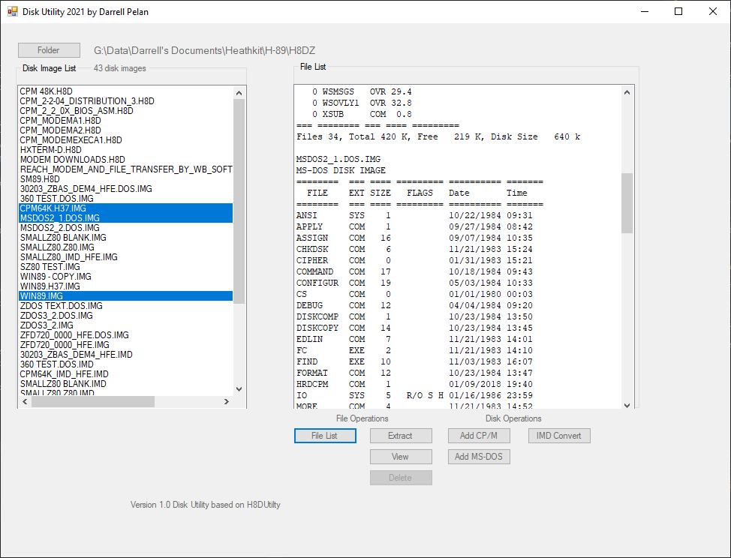

# Function Buttons

## Folder

Selects the working folder for the Disk Images.

## File List

Displays the files in each disk image selected in the Disk Image List. If no images are selected, all images in the Disk Image List window are processed. The User Area and flags for each file is displayed for CP/M images. DOS files show the flags, date, and time. Disk Image Utility will display the contents of a sub directory, but not sub directories in the sub directory.

File List does not currently support DOS IMD images.

## Extract

Extracts selected files in in the File List window. If no file is selected, Disk Image Utility will offer to extract all files. Extracted files are placed in a directory in the Disk Image List target folder created from the Disk Image file name with “_Files” appended.

Extract does not currently support DOS IMD images

## View

Displays text in the first selected file. Currently, only CP/M formats in IMG and H8D are supported.

## Delete

Future capability

## IMD Convert

Converts IMG and H37 files to IMD format. You can then use HxC Floppy Emulator to convert the image to HFE format for use on HxC flashed Gotek drives. Disk images need to end in DOS.IMG for Disk Image Utility to properly recognize the image for conversion.

Converts IMD files to IMG file format. DOS files need to end in DOS.IMD for Disk Image Utility program to properly recognize the image as a DOS file. The file name does not impact the conversion from IMD to IMG.

You will need to select Folder and the click Ok to rescan the folder to see the new files.

## H8D Convert to Soft Sector

Converts H8D files to IMG file format. The disk type byte at location 5 in sector 1 is updated to 0x60 to represent a 100k SS disk format. You will need to select Folder and the click Ok to rescan the folder.

## Add CP/M / Add MS-DOS (IMG and H8D only)

Opens a new window That allows you to create blank images in several formats. When opened using Add CP/M, only CP/M files are displayed in the Disk Image List. Not surprisingly, when opened with the Add M-DOS button, only MS-DOS files are displayed.

Double clicking on a file in the Disk Image List opens a new directory window to select individual files to add to the image.

### Create an Empty File

Clicking on the button will create the format on the button. After the image is created, a new directory window will open to add files to the image. If you only want the empty file, simply close the window.

In order to see the file in the Disk Image List window the left side, click the **Folder** button and then click OK. This will cause Disk Image Utility to rescan the directory.

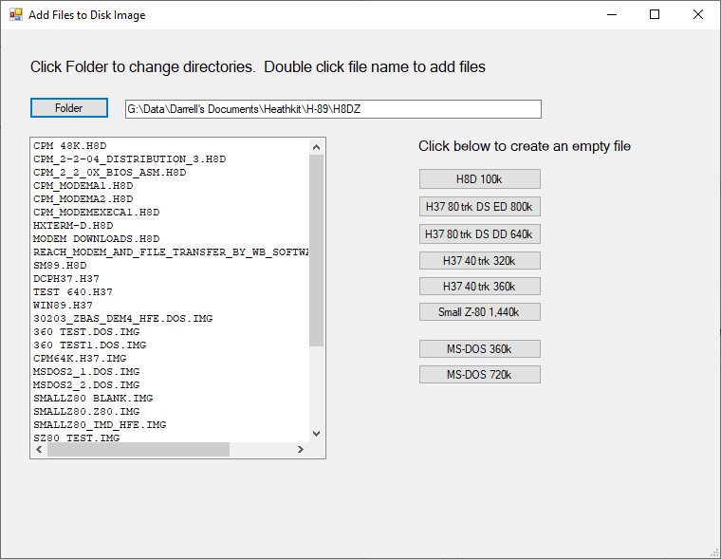

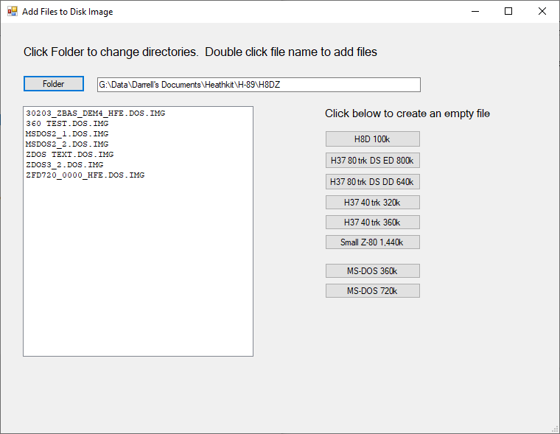

You will need to select Folder and the click Ok to rescan the folder to see the new files.

# Appendix

## Disk Format Details

**CP/M formats**

|  |  |  |  |  |  |  |  |  |
| --- | --- | --- | --- | --- | --- | --- | --- | --- |
| **Disk ID Marker** | **Sectors per Track** | **Sector Size** | **# Tracks** | **# Heads** | **Disk Size** | **File Extension** | **File Extension** | **File Extension** |
| 0xff | 18 | 512 | 80 | 2 | 1,474,560 |  | IMG | IMD |
| 0x6f | 5 | 1024 | 80 | 2 | 819,200 | H37 | IMG | IMD |
| 0x6b | 16 | 256 | 80 | 2 | 655,360 | H37 | IMG | IMD |
| 0x67 | 5 | 512 | 80 | 2 | 409,600 | H37 | IMG | IMD |
| 0x62 | 16 | 256 | 40 | 2 | 327,680 | H37 | IMG | IMD |
| 0x63 | 9 | 512 | 40 | 2 | 368,640 | H37 | IMG | IMD |
| 0x60 | 10 | 256 | 40 | 1 | 102,400 | H37 | IMG | IMD |
| 0xE5 | 10 | 256 | 40 | 1 | 102,400 | H8D |  | IMD |
| 0x00 | 10 | 256 | 40 | 1 | 102,400 | H8D |  | IMD |

H37 should most likely be phased out.

**DOS Formats for Z-100**

|  |  |  |  |  |  |  |  |
| --- | --- | --- | --- | --- | --- | --- | --- |
| **Disk ID Marker** | **Sectors per Track** | **Sector Size** | **# Tracks** | **# Heads** | **Disk Size** | **File Extension** | **File Extension** |
| 0xfd | 8 | 512 | 40 | 2 | 327,680 | DOS.IMG | IMD |
| 0xfrf | 9 | 512 | 40 | 2 | 368,640 | DOS.IMG | IMD |
| 0xf9 | 8 | 512 | 80 | 2 | 655,360 | DOS.IMG | IMD |
| 0xfe | 8 | 1024 | 77 | 2 | 1,261,568 | DOS.IMG | IMD |

## File Conversion Notes

* Dunfield IMD files image skew matches physical disk. For an 800k disk, the first sector is 3.
* H37 has skew of 3, sector 1 is first but in same order as Dunfield IMD
  + To convert H37 to IMG
    - Convert to IMD
    - Then convert to IMG
* MS-DOS IMD disk has skew = 1
* IMG files are sequential order, skew = 1
* IMG conversion to IMD keeps skew = 1
* IMD conversion to IMG changes skew to 1